REVIEW FOR DAVE SHARP’S SECRET SEVEN CD “7” on Blue Pie Records
Track listing: Africano; Chrispy Underground; Skeleton Key; Blackout; Boop Bwee Ahh; The Seventh Secret; Lootmar (Wind Song); Africano [Radio Edit]; Can I Be Your Squeeze?
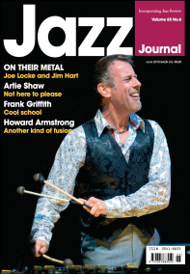
From JAZZ JOURNAL MAGAZINE UK Vol. 63 No. 6 June 2010
http://www.jazzjournal.co.uk/
Dave Sharp’s Secret Seven
7 [Vortex Jazz 1969]
Groove jazz with shots of latin and jazz funk from bassist Sharp here, joined by former Motown saxophonist Chris Kaercher- who contributes a fabulous Bobby Wellins-style solo to Blackout-plus Hammond B3/piano and drums with a cast of special guests. It mostly ain’t subtle, mostly, but swings like hell.

